Assignment 02 - Familiarize with Postman Scripting

Learning objectives
- Learn how to explore an API and understand the business functioning
- Understand some fundamentals about postman scripting
- how to check the status codes in a response
- how to check data in API response and headers and
- how to use some of the provided assertions so that you can check anything that you need to.

Target API
The API that we will test here is a demo API, which is provided freely on the following site: https://swapi.dev/api.

Explore and understand target API
- Draw up business entity relationship using Lucidchart, an online diagramming tool.
- Use curl, a command line tool, to invoke all endpoints.
- Map out API endpoints, http methods, status code, and API functioning.

Some fundamentals about Postman scripting

Using the pm object
The pm object is a JavaScript object that Postman provides that gives you access to data from your requests and their responses. It also lets you access and manipulate variables and cookies. In fact, most of the JavaScript functionality that you will use in Postman is provided through the pm object.

Using the pm.test method
The test method is an asynchronous method that you can use to set up each check that you want to do. It takes in two arguments. The first one is the name of the test as a string, in this case "Status code is 200". Note that enclosing text in double (or single) quotes means that it is a string. This name will appear in the test result output, so you will want to make sure that it accurately describes what the test is doing so that you can better understand your test results.
The second argument needs to be a function that does the actual check that you are interested in. JavaScript gives a lot of shortcuts for this kind of stuff, and so you can define your function directly in the argument to the test method. In this case, the snippet is using an unnamed (or anonymous) function. This is the only spot this function is being used so it does not need a name. The function is defined by function(), which just means that you are creating an anonymous function. Since there is nothing in the brackets, we know that this function does not take in any arguments. However, the pm.test method does expect the function to return a Boolean (a value that is either true or false). It should not return a string, or an integer, or anything like that. You can do whatever checks you want inside the function, but you need to ensure that it returns a Boolean value.
The actual work that the function does is then defined inside the curly braces.

Using Chai assertions in Postman
There is one last piece to this test that we haven't looked at yet. That is the actual code that is being executed. The snippet is using the pm object to access the response data. The pm.response object contains various information about the response. In this example, you are getting the response and then creating an assertion on that response to check that the response has the status 200.
Assertions in Postman are based on the capabilities of the Chai Assertion Library. This is a very common JavaScript assertion library and is used in many JavaScript unit testing frameworks. The Chai framework supports Test-Driven Development (TDD) and Behavior-Driven Development (BDD) approaches. Postman uses the BDD style of Chai assertion. You can read more about the various assertions on the Chai website (https://www.chaijs.com/api/bdd/).
Chai assertions are very nice to read. They match up well with how we would speak about the assertions in natural language English. I'm sure that you were able to figure out that when the snippet said to.have.status(200), it meant that we expect the response to have a status of 200. This readability makes it easy to figure out what a test is checking; however, I have found that it can be a bit tricky sometimes to figure out how to craft these assertions. As we go through this chapter, I will show you several different assertions. As you see (and create) more of them, it will get easier to use.

Checking the status code in a response
The Tests tab in Postman is where you define the things that you want to check on each request. You can find this tab on each request. Go to the Tests tab for the request you made and as you can see in the following figure, the left-hand panel has several different snippets available for you to use:
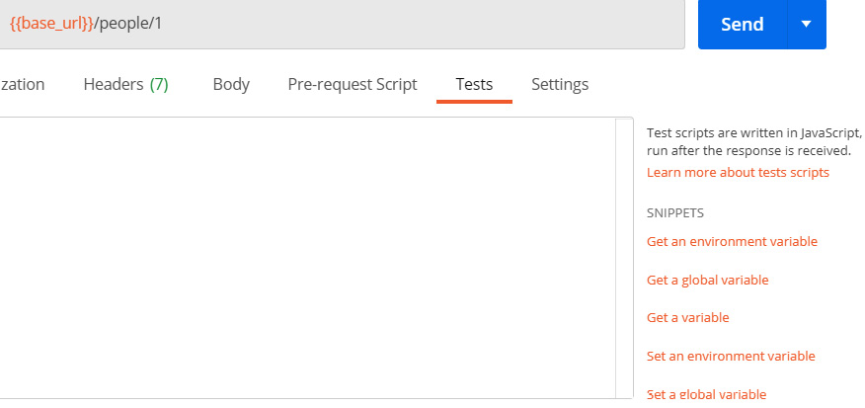
Figure 1 - Test snippets
These snippets are little bits of JavaScript code that Postman provides to make it easy to add some common checks to your tests. Scroll down in the list until you see one that says Status code: Code is 200 and click on that one. When you do that you will see that Postman adds some JavaScript code into the test panel. You should see a code that looks something like the following figure:

Figure 2 - Snippet checking that the status code is 200
Now, if you send the request, this code will check that the request returns a status code of 200. If the request returns any other status code, this check will fail.

Try it out
This is very basic check, but I want you to take a couple of minutes to make sure you understand how it works. Try changing the expected status code and ensure that it fails. The test will be run after you send the request and you can view the results on the Test Results tab in the response section. If you click on the Test Results tab, you should see something that looks like this:
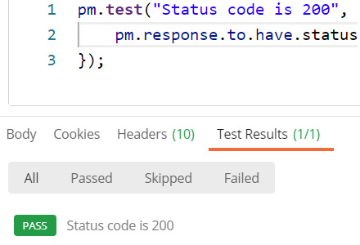
Figure 3 - Check on the test results
The script is asserting that the response should be 200. Play around with this assertion a bit and make sure you understand what is going on. Can you make it fail? Make sure you understand how it works. I will be showing you some more assertions, but they share many of the same components as this one so make sure you fully understand what is going on here before moving on to look at how to check data in the body of a response.

Checking the body of a response
You have seen how to verify that an API response has the status code you expect it to, but there is a lot more that you can do with tests in Postman. You can check many things in the data of the response itself. I want to show you a couple of examples of how to do that, so that you can have the confidence to create these kinds of assertions on your own.

Checking whether the response contains a given string
For the first example, I will show you how to check that a response contains a string that you expect it to. The snippets are a very helpful way to learn about the available functionality, so let's use another one to look at how you can verify that the body of a request has the correct data. Scroll down in the snippets section until you see a snippet called Response body: Contains string. Ensure that your cursor is on the last line of the tests text field and then click on the snippet to add the code for it to the tests.
You should see a code snippet that looks like this:
pm.test("Body matches string", function () {
pm.expect(pm.response.text()).to.include("string_you_want_to_search");
});
As you can see, there is a lot of similarity between this snippet and the previous snippet. It once again uses the pm.test method to define the test and we give it a function that does an assertion. In this case, the assertion is a bit different, though. You are still looking for response data with the pm.response object, but now you have the .text() method attached to it. Since the pm.response object is just that, an object; you need to turn it into a string before you can check whether it includes the string you want. This is what the .text() method does. It turns the response object into a string that Postman can search through. Replace string_you_want_to_search with a search term such as Luke. Give the test a more descriptive name as well – perhaps something like Check that the response body contains Luke – and send the request again. In the Test Results tab, you should now see that there are two passing tests.

Checking JSON properties in the response
Now let's look at another example snippet. This time choose the Response body:JSON value check snippet. You will see that the following code is added to the tests:
pm.test("Your test name", function () {
var jsonData = pm.response.json();
pm.expect(jsonData.value).to.eql(100);
});
There are a couple of new things in this snippet. In the first place, you can see the use of the var keyword. This is used in JavaScript to define a variable, so in this case, we are creating a variable called jsonData. The data for this variable is coming from the pm.response object, but this time instead of calling .text() to convert it into a string, the snipped is calling .json(), which will turn it into JSON. JSON stands for JavaScript Object Notation and it is a format that is used for storing and transporting data. It is structurally similar to a dictionary or hash map object and is a very common standard. Many APIs will return data in a JSON structure. The Star Wars API is no exception to this and so you can directly convert the response object for a call to that API into JSON.
The variable can then be used in an assertion. You can see that Postman has put in a default assertion that is expecting the value of the jsonData variable to equal 100. If you send the request, you will see that this test fails with an assertion error where it tells you that it expected undefined to deeply equal 100, as you can see in the following figure:
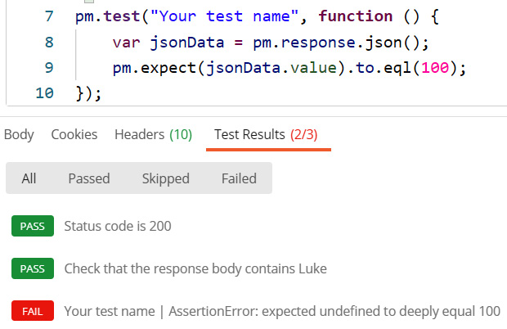
Figure 4 - Test assertion fails
This warning sounds a bit cryptic, but all it is telling you is that it was trying to compare the two values that you gave and one of them was undefined while the other was 100. It was expecting those two values to be equal and hence the assertion failed. This tells you that jsonData.value is undefined. But why? Well, in order to understand that, let's look at the console log.
In JavaScript you can log things to the console. This is similar to printing in other languages. Since Postman is using JavaScript, you can use console.log to print out information. This is very helpful when trying to debug something, so let's try it out here. In the line after the variable definition, add this code:
console.log(jsonData);
Now send the request again. In order to see the data that has been logged, you will need to open the console in Postman. As shown in the following figure, you can do that by clicking on the Console button at the bottom of the Postman app:

Figure 5 – Open the Postman console
At the bottom of the console, you should see the jsonData object that you logged:
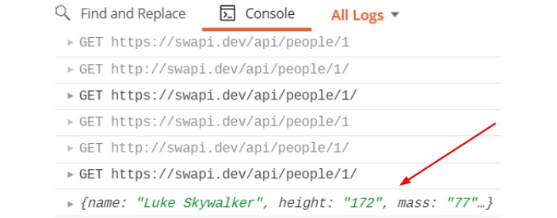
Figure 6 - Logged object
This looks like what you'd expect to see, so why does the assertion think that things are undefined? Well, we need to look for a minute at the .value operator. This snippet is a bit tricky. This looks like it is a valid operator, but it is actually just a placeholder to let you know that you need to get some value out of the jsonData object. In JavaScript, it is easy to do that with dot notation. So, if you want to get the height field, you can just reference it by its name like this:
jsonData.height
You will need to change what you expect it to equal. In this case, it should be equal to "172", so put that in to make the line look this this:
pm.expect(jsonData.height).to.eql("172");
IMPORTANT NOTE
You can access the properties of objects in JavaScript using either bracket or dot notation. They both give you access to the same information, but I think that dot notation is more readable than using bracket notation, and so I will stick with that throughout this assignment. In dot notation, you can access the properties of an object by using the syntax objectname.propertyName. You can also access nested objects in this way, and so you could see something like objectname.subobjectName.propertyName.
This example should give an idea of the kinds of options you have for checking response data. Many APIs send responses in JSON format, and with the options you have learned about in this example, you should be able to create checks for almost anything that you might get in an API response. In order to make sure that you understand what is going on here, though, I would encourage you to explore this a bit more.

Try it out
You have a seen a couple of examples that show how to check for data in API responses. Now I want you to try your hand at this without step-by-step examples. See if you can take what you have learned and put it into practice on your own. You can play around and set yourself a few challenges on your own if you want. To help you get started, here are a few ideas of tests that you could create:
- Create a test that verifies Luke's eye color.
- Create a test that verifies the URL of Luke's home world.
Now that you know how to check data in the body of a response, it's time to look at how to check the headers of responses.

Checking headers
An API response includes a status code, a body, and a header. Sometimes, there are important things in the header that you want to be sure are getting sent back correctly. As you might guess, you can create assertions in Postman that let you check header data. Once again, the easiest thing to do is to start with a snippet – in this case, the Response header: Content-Type header check snippet. Choosing that snippet should add this code to the tests:
pm.test("Content-Type is present", function () {
pm.response.to.have.header("Content-Type");
});
This is similar to the code in the body snippets. The only difference really is that the assertion has the .header assertion in it. This is an assertion that is specific to Postman. Postman has a Chai plugin that extends the common Chai assertions to give you access to a few custom ones that they provide. You could build this same assertion without using this custom assertion type, but it would be more complicated to do so.

Custom assertion objects in Postman
You may not have noticed, but you actually used another custom assertion object in one of the earlier examples that I went through previously. When checking the status code, the .status assertion is a custom assertion type. Postman has also created several other assertions like this that can make it a lot easier to assert on common response objects. I have listed the custom assertion methods that Postman provides along with examples of how to use them. These assertions are specifically designed to help you verify API response, and so you will probably use them a lot when creating tests in Postman:
- .statusCode: This assertion checks whether the numerical status code of the response matches the one you specify. Here's an example usage:
pm.response.to.have.statusCode(200);
- .statusCodeClass: This assertion checks whether the response code is in the right class. Class 2 is a status code that is in the 200s and 3 is one in the 300s, and so on. Here's an example usage:
pm.response.to.have.statusCodeClass(2);
- .statusReason: This assertion checks whether the reason, which is a text response corresponding to the status code, matches what you specify. Here's an example usage:
pm.response.to.have.statusReason('OK');
    - .status: This assertion allows you to verify the status by specifying either the status code or the status reason. It is essentially a combination of .statusCode and .statusReason assertions. Here are two example usages:
pm.response.to.have.status('OK'); or pm.response.to.have.status (200);
- .header: If you only input one argument, this assertion will check for the existence of a header that matches that argument. If you specify two arguments, it will check that the given header (specified by the first argument) has the given value (specified by the second argument). Here are two example usages:
pm.response.to.have.header ("Content-Type");
pm.response.to.have.header ("Content-Type", "application/json;");
- .withBody: This assertion checks that the response has a body. Here's an example usage:
pm.response.to.be.withBody;
- .json: This assertion checks whether the body is in JSON format. Here's an example usage:
pm.response.to.be.json;
- .body: This assertion can be used to check whether the response has a body and whether that body contains a given value. You can specify the expected value as a simple string, in which case it will check whether that string is found anywhere in the body. Alternatively, you can specify the expected value as a regular expression or as a JSON key/value pair. In those cases, the assertion will search for a match to your query. Here are some example usages:2
pm.response.to.have.body;
pm.response.to.have.body("some text");
pm.response.to.have.body(<regex>);
pm.response.to.have.body({key:value});
- .jsonBody: If no argument is specified, this assertion checks whether the body of the response is in JSON format. Otherwise, it will check for the existence of the given JSON object in the body. Here are some example usages:
pm.response.to.have.jsonBody;
pm.response.to.havejsonBody({a:1});
- .responseTime: This assertion checks how long the request took. It can also be used to check whether a response time was above or below a given value or if it is within a given range. The time values are given in milliseconds. Here are some example usages:
pm.response.to.have.responseTime(150)
pm.response.to.have.responseTime.above(150);
pm.response.to.have.responseTime.below(150);
pm.response.to.have.responseTime.within(100,150);
- .responseSize: This assertion checks the size of the response. It can also be used to check whether a response size is about or below a given value of if it is within a given range. The response sizes are given in bytes. Here are some example usages:
pm.response.to.have.responseSize(50);
pm.response.to.have.responseSize.above(50);
pm.response.to.have.responseSize.below(100);
pm.response.to.have.responseSize.within(50,100);
- .jsonSchema: This assertion checks whether the response follows the specified schema. Here's an example usage:
pm.response.to.have.jsonSchema(mySchema);
These assertions can help you deal with the various responses that you will get when making API requests. This list gives some simple examples to help you get started with using these assertions, but don't stop there. You can use these assertions in combination with standard Chai library as well. For example, you could add .not to the assertions in order to negate any of them. Use these listed examples as starting points for building out your own assertions as you create your tests.

Creating your own tests
I have shown you several examples using the snippets that Postman has created in order to help people get started with creating tests. These snippets are a great place to start if you don't know much about JavaScript as they give very clear examples of how to do certain things. However, they are just a starting point. Since assertions in Postman are built on JavaScript, there is a lot of flexibility and power in what you can do. You may benefit from learning some basic JavaScript, but even without that you should be able to create a lot of your own assertions merely by using the snippets along with the kinds of commands you have learned about in this section.

Try it out
As I keep repeating in this book, the best way to learn is by doing, so try creating a few of your own assertions. Using the Star Wars API, see if you can create assertions to validate the following:
- Check that the server (a header) is nginx.
- Check that the response time for this call is less than 500 milliseconds.
- Check that Luke appears in 4 films.
You can check out my solutions to these in the GitHub repository for this book, but make sure you first try to figure them out on your own. Now that you have a good grasp on how to use assertions in a request, I want to look at how to share them across multiple tests using folders and collections.

Creating folder and collection tests
I have shown you how to create tests that can verify that a request is correct. Some assertions, though, might be the same across multiple tests. For example, you might have a set of positive tests that should all return a status code of 200. You can create an assertion in each of the requests that you set up, but there is an easier way to do it. In Postman, you can add tests assertions to folders and collections.
If you have several requests in a folder and you add a test assertion to the folder, that assertion will run after each request in the folder has completed. Let's look at an example with the following steps:
- Add a folder to the SWAPI collection called Luke.
- Drag the Get First Person request that you were working with earlier into that folder and then add another request to that folder called Luke's home world.
- Set the URL of the request to {{base_url}}/planets/1.
- Now, edit the folder and on the Tests tab, and add a test to check that Luke and his home world both appear in film 1:
pm.test("Check that they are in film 1", function () {
var jsonData = pm.response.json();
pm.expect(jsonData.films).to.contain("http://swapi.dev/api/films/1/");
});
- Go to the Get First Person and Luke's home world requests, and for each of them send the request.
You will notice in each case that the Test Results area shows that Postman has run the check that was defined in the folder. You can set up similar checks at the collection level as well. Any tests that you add to the collection will run any time a request in the collection is sent. Setting up tests in the collection works the same as doing it in a folder, so I will leave it up to you to play around with that.
Being able to share tests with multiple requests is helpful, but you may also need to clean up after yourself sometimes. You might have data or variables that you don't want to persist after a request has complete and so there are times when you will need to clean up after your tests.

Cleaning up after tests
In many testing frameworks, you will have the ability to run teardown scripts. These are essentially scripts that let you clean up any variables or values that you don't want to have persist once your test is complete. Postman does not have an explicit section where you can do something like this. However, if you have stuff that needs to be cleaned up after a test, you can do so right in the Tests tab.
One thing to be aware of here is the order of executions. Where should you put your cleanup scripts? Should you put them in the Tests for a request or in a folder or collection? Scripts created at the folder or collection level will run after each request, but what order should they be run in?
After a request completes, Postman will first execute the test scripts from the collection, and then the script from the folder and finally the scripts from the request. This means that any variables created in a request test script can't be cleaned up in a collection or folder. In general, the best practice would be to clean up any variables in the same place where they are created. So, if you make a temporary variable in a collection that you want to remove when you are done, do so in the collection where you made it. I think this is the easier way to manage test data cleanup, but there may be times when you need to pass a variable around and so need to clean it up elsewhere. When doing so, knowing the execution order will help you avoid errors.
So far in this assignment we have talked a lot about running tests after a request is sent. You have seen how to use the snippets in Postman to help you get started with creating tests. You've seen how to check various parts of a response, ranging from the body to the header, and you've also seen how to use the many built in assertions that Postman provides. You can create your own tests, and now it is time to turn your attention to what you can do before a request has even been sent.

